Edge Intelligence Lab
Dhayanidhi R S
25MML0025

To design and implement the pipeline for Object Detection in Videos using Yolov8:

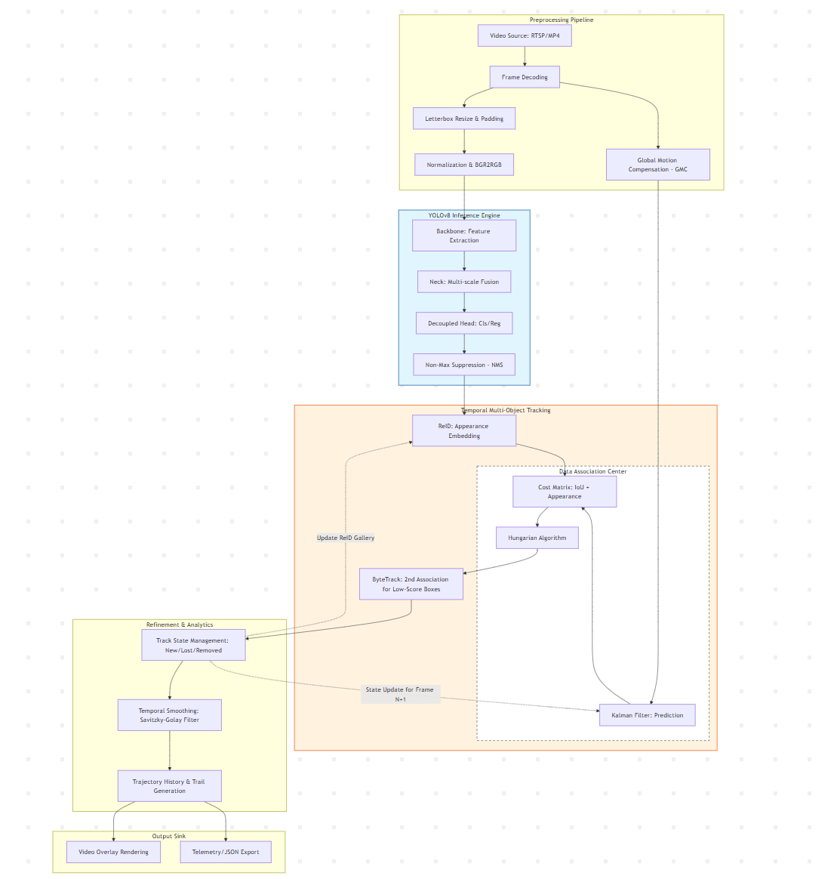

Workflow:
- Frame Acquisition & Decoding: Capture the raw video stream and decode frames into a processable format (BGR/RGB).
- GMC Calculation: Analyze the global motion between the current and previous frame to compensate for camera movement/panning.
- Preprocessing: Apply Letterbox resizing (to maintain aspect ratio), normalization, and color-space conversion for the model.
- YOLOv8 Inference: Run the image through the Backbone, Neck, and Decoupled Head to generate raw bounding boxes.
- Post-Inference (NMS): Apply Non-Maximum Suppression to remove redundant overlapping boxes and keep only high-confidence detections.
- Feature Extraction (ReID): Generate a visual embedding (appearance "fingerprint") for each detected object using a CNN.
- Kalman State Prediction: Predict the "new" location of existing objects from the previous frame based on their last known velocity and GMC data.
- First Association (Cost Matrix): Match high-confidence YOLO detections with Kalman predictions using a combined score of IoU (spatial) and ReID (visual).
- Hungarian Matching: Solve the linear assignment problem to optimally pair detections to existing tracks.
- Second Association (ByteTrack): Attempt to match low-confidence detections (blurred/occluded) with remaining "lost" tracks to prevent ID switches.
- Track State Management: Update track statuses (Mark as New, Tracked, Lost, or Removed if missing for too long).
- Temporal Feedback Loop: Feed the updated track states back into the Kalman Filter and ReID gallery to inform the next frame's prediction.
- Smoothing & Refinement: Apply filters (like Savitzky-Golay) to the box coordinates to eliminate jitter and draw motion trajectories.
- Output Sink: Render the final annotated frames to a video file or stream the metadata (JSON/Telemetry).

